

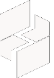

MICROSOFT ARCHITECTURE BEST PRACTICE FOR CLOUD AI PLATFORM

USECASE: BASELINE ARCHITECTURE FOR AN AZURE KUBERNETES SERVICE (AKS) CLUSTER

Document Title | Microsoft Cloud Center of Excellence Overview
Presales/Technical Head | Tushar Mehrotra/Rohit Pandey
CCoE Lead | Ravishankar N
Creation Date | December 2025
Version | Description | Modified by | Date | Approved by | Date
1 | Initial Architecture design | Ranu Kumar | 15/12/2025 | Ravi Shankar | 15/12/2025
2 | Security by Default | Ranu Kumar | 15/02/2026 | Ravi Shankar | 15/02/2026
Contents
1
1. Executive Summary 3
2. Scope and Applicability 3
3. Business Scenario Overview 3
4. Reference Architecture Overview 4
4.1 Architecture Description 4
5 Logical Architecture Components 4
5.1 Container Platform – Azure Kubernetes Service 4
5.2 Networking and Connectivity 5
5.3 Ingress and Traffic Management 5
5.4 Deployment and Configuration Management 6
6 Architectural Best Practices 6
6.1 Platform Isolation and Design 6
6.2 Security by Default 6
10 Conclusion 7

Baseline architecture for an Azure Kubernetes Service (AKS) cluster

Executive Summary
This document defines a standardized reference architecture and architectural best practices for deploying and operating containerized workloads on Azure Kubernetes Service (AKS). The architecture represents a secure, scalable, and production-ready baseline for running business-critical applications on Kubernetes in Azure.
It is curated and maintained as an internal architecture standard to ensure consistency, reliability, and operational excellence across AKS-based solution designs and customer deployments.

Scope and Applicability
This reference architecture applies to:
- Containerized application platforms built on Azure Kubernetes Service
- Internet-facing and internal application workloads
- Microservices and API-based architectures
- Enterprise and mid-market production environments
- Multi-environment deployments (development, test, production)
The architecture is suitable for single-region and multi-region deployments and can be adapted to meet organizational security, compliance, and availability requirements.

Business Scenario Overview
Organizations adopt Kubernetes to improve application scalability, portability, and deployment velocity. However, production Kubernetes environments require careful architectural design to address security, networking, identity, reliability, and operational complexity.
- A well-defined AKS baseline architecture provides:
- A secure and isolated platform boundary for workloads
- Predictable networking and ingress patterns
- Integrated identity and access management
- Built-in resilience, scalability, and observability
- Standardized operational and lifecycle management practices

Reference Architecture Overview

Architecture Description
The AKS baseline architecture represents a hub-and-spoke-style platform deployment where Kubernetes workloads are isolated within a dedicated virtual network and integrated with shared platform services such as identity, monitoring, and security.
High-Level Architecture Description
- Containerized applications are deployed to a managed AKS cluster
- Networking is implemented using private cluster endpoints and controlled ingress
- Identity is centrally managed using Microsoft Entra ID
- Traffic is secured using network controls and application-level protection
- Observability and operations are integrated using Azure monitoring services
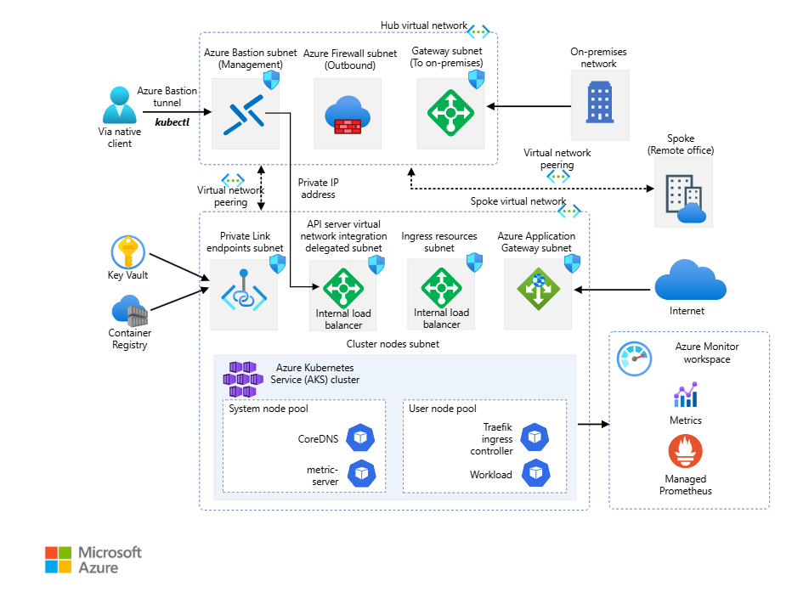

Logical Architecture Components

Container Platform – Azure Kubernetes Service
The AKS cluster provides the managed Kubernetes control plane and worker nodes. Key characteristics include:
- Managed Kubernetes versioning and control plane operations
- Node pools aligned to workload characteristics
- Autoscaling for compute and application demand
- Support for rolling upgrades and maintenance operations

Networking and Connectivity
Network design follows a secure and segmented model:
- Dedicated virtual network for the AKS cluster
- Separate subnets for node pools and supporting services
- Controlled ingress using application gateways or ingress controllers
- Outbound traffic management using defined egress paths
Network policies are applied to control pod-to-pod and pod-to-service communication.

Ingress and Traffic Management
Application traffic is handled through managed ingress components:
- TLS termination and certificate management
- Layer-7 routing to backend services
- Integration with web application protection capabilities
- Support for internal and external application endpoints
This approach provides consistent and secure access to applications running in the cluster.
Identity and Access Management
Identity is integrated throughout the platform:
- Authentication and authorization via Microsoft Entra ID
- Kubernetes role-based access control (RBAC)
- Managed identities for pod-to-Azure service communication
- Least-privilege access for platform and application operators
This ensures secure access while enabling developer productivity.

Security and Protection
Security is implemented as a layered design principle:
- Private AKS cluster endpoints
- Network security groups and routing controls
- Container image scanning and vulnerability management
- Secrets management using managed services
- Application-level protection using web application firewalls
Security controls are embedded into both the platform and workload layers.
Observability and Operations
Operational visibility and management are enabled through:
- Centralized logging and metrics collection
- Application and infrastructure monitoring
- Alerting for platform and workload health
- Integration with operational dashboards and runbooks
These capabilities support proactive operations and rapid issue resolution.

Deployment and Configuration Management
Workload and platform configuration is managed using declarative practices:
- Infrastructure and configuration defined as code
- Kubernetes manifests and package-based deployments
- Environment-specific configuration overlays
- Controlled promotion of changes across environments
This approach improves consistency and repeatability across deployments.

Architectural Best Practices

6.1 Platform Isolation and Design
- Use dedicated AKS clusters for production workloads
- Separate system and user node pools
- Isolate cluster networking from shared services

6.2 Security by Default
- Use private clusters where possible
- Enforce role-based access and least privilege
- Store secrets securely and avoid hard-coded credentials
- Scalability and Resilience
- Enable cluster and node autoscaling
- Deploy applications across multiple nodes and availability zones
- Design applications to be stateless where possible
- Operational Excellence
- Automate cluster provisioning and configuration
- Monitor platform and application health continuously
- Plan and test upgrade and disaster recovery procedures

Conclusion
The Azure Kubernetes Service baseline reference architecture described in this document provides a secure, scalable, and production-ready foundation for running containerized workloads on Azure. By standardizing on well-defined architectural patterns and operational practices, organizations can accelerate application delivery while maintaining strong security, reliability, and governance.

